

Business Requirements Document (BRD)
Project: Linux Cluster Monitoring Agent
Prepared by: Aditya Anupam Shukla
Prepared for: Jarvis

Project Sponsor: Jarvis
Client Acceptor: Trevor Todo
Project Manager: Trevor Todo

Last Updated: May 18, 2025
Creation Date: May 20, 2025

Table of Content
1. Executive Summary 3
2. Project Objectives 3
3. Needs Statement 3
4. Project Scope 3
4.1. In Scope 3
4.2. Out of Scope 3
5. Requirements 4
5.1. High-Level Requirements 4
5.2. Technical Requirements 4
6. Key Stakeholders 4
6.1. Stakeholder Table 4
7. Schedule, Timeline, and Milestone Deadlines 4
7.1. Milestone Table 4
7.2. Gantt Chart 5
8. Cost-Benefit Analysis 5
8.1. Costs 5
8.2. Benefits 5

Executive Summary
The Linux Cluster Monitoring Agent project was designed to automate the monitoring of Linux cluster nodes by collecting hardware and resource usage data, storing it in a centralized PostgreSQL database within a Docker container, and ensuring continuous data collection via crontab. The project was successfully implemented within one week, ahead of schedule, showcasing operational efficiency and technical preparedness. The resulting solution supports proactive infrastructure management and aligns with organizational goals around automation, reliability, and operational uptime.

Project Objectives
- Deploy an automated monitoring system that collects hardware and usage data from all Linux cluster nodes.
- Ensure 100% automated data collection with updates every minute, and store the data in a persistent PostgreSQL database.
- Implement the system using existing technologies such as bash scripts, Docker, PostgreSQL, and cron jobs for ease of deployment and maintenance.
- Support IT operations by improving cluster reliability and minimizing manual monitoring efforts.
- Complete the entire development, testing, and deployment cycle within 30 days of project kickoff (by 2025-06-20).

Needs Statement
Linux clusters are critical infrastructure components, and their health impacts service availability and performance. Currently, monitoring is manual and fragmented, leading to delayed detection of performance issues or node failures. The organization needs an automated, scalable, and maintainable monitoring system that continuously collects vital data and provides actionable insights. This solution will reduce downtime, improve troubleshooting speed, and enable proactive infrastructure management, thereby supporting business continuity and operational excellence.

Project Scope

In Scope
- Setup of a PostgreSQL database running inside a Docker container with persistent storage.
- Development of bash scripts to collect static hardware info (host_info.sh) and dynamic resource usage data (host_usage.sh).
- Automation of data collection using crontab to execute host_usage.sh every minute.
- SQL schema creation and query scripts for storing and analyzing collected data.
- Logging, error handling, and secure passing of database credentials.
- Creation of comprehensive documentation (README.md) for deployment, usage, and troubleshooting.

Out of Scope
- Development of user interfaces or dashboards for data visualization.
- Integration with external alerting or notification systems beyond logging.
- Support for non-Linux platforms or cluster environments.
- Advanced predictive analytics or machine learning features.

Requirements

High-Level Requirements
- Automated collection and storage of hardware and usage data from cluster nodes.
- Scheduled script execution ensuring continuous data collection without manual intervention.
- Reliable data persistence with recovery from container or system restarts.
- Ability to query and analyze collected data to identify system health trends.

Technical Requirements
- Use PostgreSQL as the database engine running in a Docker container with volume mapping for persistence.
- host_info.sh to gather hardware details once and store in host_info table.
- host_usage.sh to gather CPU, memory, disk, and network usage metrics every minute and store in host_usage table.
- Crontab configuration to automate execution of host_usage.sh.
- Scripts accept parameters for database host, port, name, user, and password for flexible deployment.
- SQL DDL scripts to create required tables and indexes for efficient storage and querying.
- Query scripts for data retrieval and performance analysis.
- Logs stored in /tmp/host_usage.log or configurable location.

Key Stakeholders

Stakeholder Table
Stakeholder | Role / Responsibility
Linux Cluster Administration Team | Primary users; use monitoring data to maintain cluster health and performance.
Developers | Build and test scripts, Docker setup, and automation.
Database Administrators | Design and maintain PostgreSQL schemas and optimize queries.
System / Linux Administrators | Deploy scripts on cluster nodes and manage cron jobs.
Operations / DevOps | Oversee Docker container management and automation pipelines.
System Analysts / Monitoring Team | Analyse data trends and generate reports.
Project Manager / Product Owner | Define requirements, coordinate tasks, and ensure delivery on time and scope.

Schedule, Timeline, and Milestone Deadlines

Milestone Table
Milestone | Actual Completion Date
Project Kickoff | 2025-05-12
Setup GitHub Repo | 2025-04-28
Setup GitFlow | 2025-04-28
Setup PSQL & Docker | 2025-05-30
Setup Linux Host & Usage data for Nodes | 2025-05-02
Setup RDBMS PSQL Database | 2025-05-06
Setup Monitoring Agent | 2025-05-09
Deploy & automate the app.log | 2025-05-11
Update Readme.md | 2025-05-12

Gantt Chart
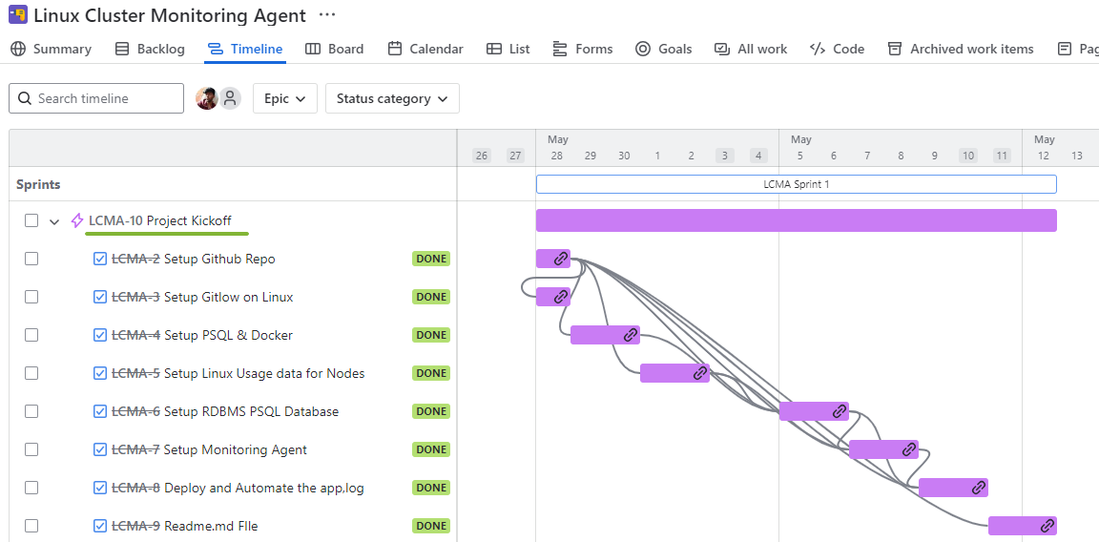

Cost-Benefit Analysis

Costs
- Developer and administrator time for design, scripting, testing, and deployment.
- Infrastructure costs for running PostgreSQL container and storage.
- Ongoing maintenance and monitoring overhead.

Benefits
- Automated monitoring reduces manual effort and human error.
- Early detection of node failures and performance issues reduces downtime costs.
- Centralized data storage allows efficient analysis and faster troubleshooting.
- Scalable solution supports growth of Linux cluster infrastructure without proportional increase in monitoring costs.

